Brandon Hackett

Module 5.2 bioSite Pictures

01/26/2024

Hobbies:



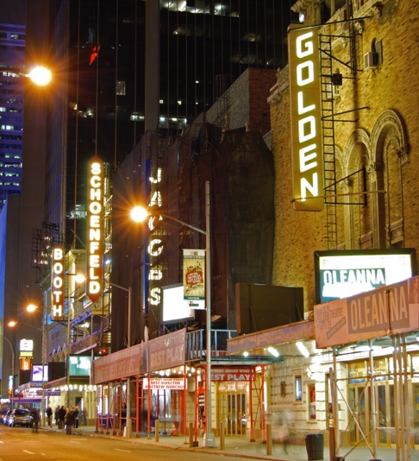



Goals, embellishments ect,

Profile:

